# Sargrab: A server statistics capture tool

## Introduction

The tool captures cpu, memory, disk and network metrics from the sar and writes them into a database. Currently, the tool only reads sar binary logs, however it could be extended to other formats.

There are three parts to the tool:

* Sargrab.sh – read the Sar binary file on each host
* Parser (batch file and shell file) – parses the output from sargrab.sh and writes into the database
* Database – contains separate tables for CPU, memory, network and disk statistics

The statistics database can be queried into order to analyse the statistics.

Statistics Database

Parser

Host1

Host1

Host1

Host1

Hosts sargrab.sh

### Pre-requisites

To run the sargarb.sh the following are required:

* A unix logon

The following are required to run the parser:

* Sar running on the hosts to be monitored
* Windows or Unix
* Java 1.6 or above
* Mysql or Oracle database

## Installation

On each host that statistics need to be captured for the sargrab.sh script needs to be installed. The script needs to be executable, i.e. chmod +x sargrab.sh.

On a Unix or Windows PC, the parser.zip needs to be unzipped.

To view or query the data in the database, download Toad for Mysql to view the data in the database: <http://toadformysql.com/index.jspa>

The details of this server are:

* Host: citihubdb.ckdislntxpum.eu-west-1.rds.amazonaws.com
* Database: sargrab
* User: citihub
* Password: password

## Usage

On the host, at a shell prompt run the following command:

$ ./sargrab.sh

The script will generate a tar file called output.<hostname>.<date>.tar. Transfer this to a server or PC that has the parser script installed on it. Extract the tar file on destination machine.

The following describes how to use sargrab parser. To run the parser for an individual SAR output file:

parser <sar file> <hostname> <date> <debug>

e.g. parser sg.sar.ip-10-235-47-228.11-18-12.all testserver 29/09/2012

It writes the cpu, memory, disk and network statistics into tables on a mysql database running on an Amazon server. The following output should be displayed.

2012.11.18 06:01:44 Starting parser for testfile.txt server Testserver4 date 01/01/2012

2012.11.18 06:01:44 Please wait ....

2012.11.18 06:01:44 Error parsing the file testfile.txt

The debug flag on the database give a detailed level of logging. It can be used as follows:

parser sg.sar.ip-10-235-47-228.11-18-12.all testserver 29/09/2012 debug

## Metrics captured

The following server metrics are captured by the tool:

* Memory
  + kbmemfree
  + kbmemused
  + %memused
  + kbbuffers
  + kbcached
  + kbcommit
  + %commit
* Network
  + rxpck/s
  + txpck/s
  + rxkB/s
  + txkB/s
  + rxcmp/s
  + txcmp/s
  + rxmcst/s
* CPU
  + %user
  + %nice
  + %system
  + %iowait
  + %steal
  + %idle
* Disk
  + tps
  + rtps
  + wtps
  + bread/s
  + bwrtn/s

## Database Tables

The following shows the database tables:

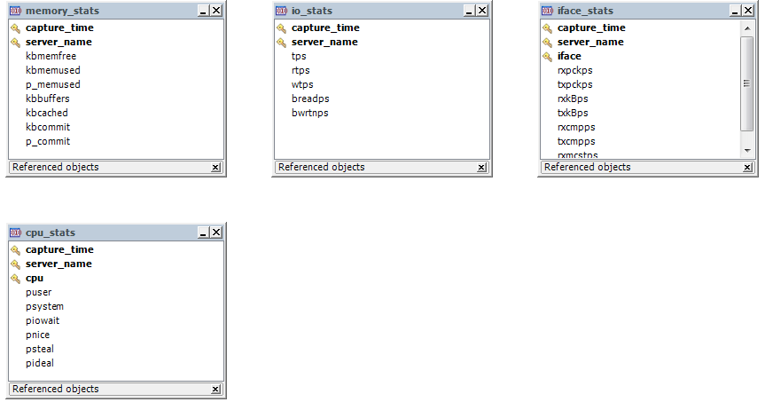

## Error Cases

If the data has already been loaded then the following error will be displayed and then parsing will be stopped. Any data before this in the file will have been written to the database.

2012.11.18 06:01:44 Starting parser for testfile.txt server Testserver4 date 01/01/2012

2012.11.18 06:01:44 Please wait ....

com.mysql.jdbc.exceptions.jdbc4.MySQLIntegrityConstraintViolationException: Duplicate entry 'Testserver4-2012-01-01 00:10:01-all' for key 'uc_stats'

at sun.reflect.NativeConstructorAccessorImpl.newInstance0(Native Method)

at sun.reflect.NativeConstructorAccessorImpl.newInstance(Unknown Source)

at sun.reflect.DelegatingConstructorAccessorImpl.newInstance(Unknown Source)

at java.lang.reflect.Constructor.newInstance(Unknown Source)

at com.mysql.jdbc.Util.handleNewInstance(Util.java:411)

at com.mysql.jdbc.Util.getInstance(Util.java:386)

at com.mysql.jdbc.SQLError.createSQLException(SQLError.java:1039)

at com.mysql.jdbc.MysqlIO.checkErrorPacket(MysqlIO.java:3609)

at com.mysql.jdbc.MysqlIO.checkErrorPacket(MysqlIO.java:3541)

at com.mysql.jdbc.MysqlIO.sendCommand(MysqlIO.java:2002)

at com.mysql.jdbc.MysqlIO.sqlQueryDirect(MysqlIO.java:2163)

at com.mysql.jdbc.ConnectionImpl.execSQL(ConnectionImpl.java:2624)

at com.mysql.jdbc.PreparedStatement.executeInternal(PreparedStatement.java:2127)

at com.mysql.jdbc.PreparedStatement.executeUpdate(PreparedStatement.java:2427)

at com.mysql.jdbc.PreparedStatement.executeUpdate(PreparedStatement.java:2345)

at com.mysql.jdbc.PreparedStatement.executeUpdate(PreparedStatement.java:2330)

at com.citihub.sargrab.CPUStatsDAO.insertStat(CPUStatsDAO.java:40)

at com.citihub.sargrab.SargrabLoader.parser(SargrabLoader.java:241)

at com.citihub.sargrab.SargrabLoader.main(SargrabLoader.java:302)

The exception raised is:com.mysql.jdbc.exceptions.jdbc4.MySQLIntegrityConstraintViolationException: Duplicate entry 'Testserver4-2012-01-01 00:10:01-all' for key 'uc_stats'

2012.11.18 06:01:44 Error: Duplicate entry 'Testserver4-2012-01-01 00:10:01-all' for key 'uc_stats'

2012.11.18 06:01:44 Error parsing the file testfile.txt

## Known Issues/Limitations

The following are known limitations of the tool:

* Time is at a 1 second level of accuracy , this is normal for Sar